Project report
Evaluation of 1 Solar Kiosk and solar water pump in Bonthe Island.
Solar Kiosk
The solar kiosk in Bonthe is completed. It is located at 54 Pie Mary Street; the southern part, Biankoi section, Bonthe town. The kiosk manager which was one of the trainees is currently managing the kiosk in Bonthe. He was trained in fixing the minor problems and was mandated to channel the major problems beyond his control to the head office in Freetown.
The solar kiosk is popular in the public and has given more hope to the community.

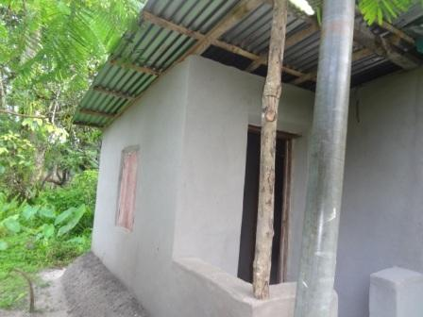
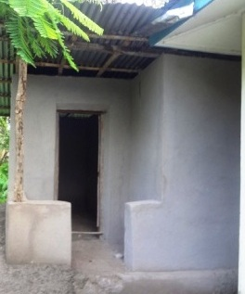

The new solar kiosk under construction

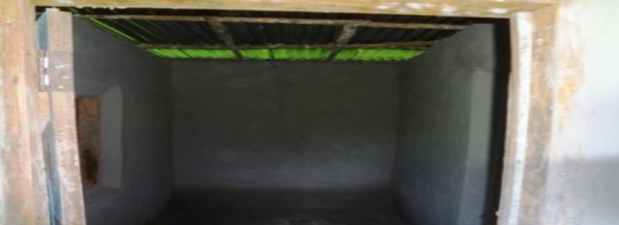

Public version

In the report of the kiosk manager, he stated that at present there are more than fifty customers on the waiting list and many more were asking. There is chance for positive outcome for this project provided all the information stated in the project manual are followed. The cooperation of the public is positive but their expectations are very high.

It is crystal clear that these current one hundred and twenty lamps are not enough because more people are waiting for this helpful facility.
According to the public opinion in Bonthe that is the customers which include teachers, traders, college and school pupils; they thank the donors and coordinators for making it possible for them to have a solar kiosk and appreciate the great service they are offering to the community. From the interviews, we also realized that people of all works of life are using these lamps for studying, selling, and home uses. They are using it because it is redeeming them to save their money, hazardous environment, and total darkness and very safe compare to flash light, candles or kerosene lamps.
During the short conversations with the customers, they however did suggest that the next solar kiosks should be located one in the southern end, one at the center and two in the north of Bonthe of the distance from their houses to the kiosk. These locations are parts of the town which are some distances away from the first kiosk and also populated that are highly in need of the lamps.
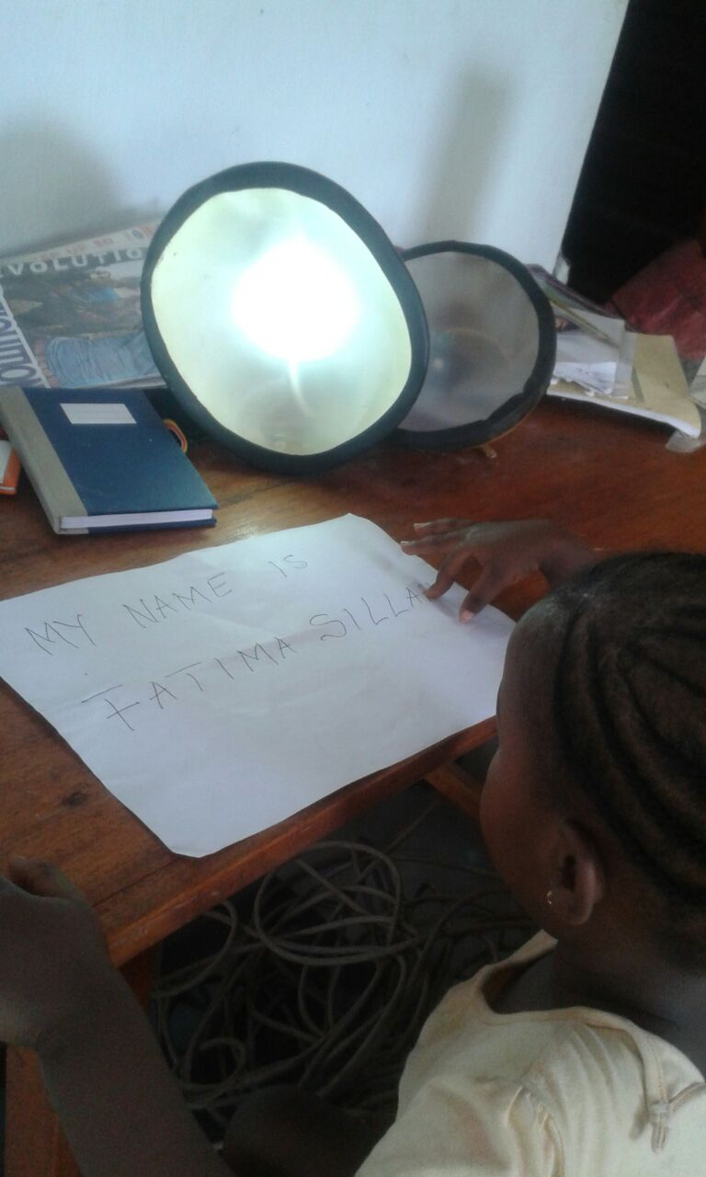
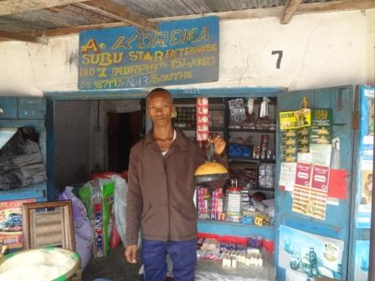

At present, more than fifty households are proudly benefiting from the solar lamps in the Bonthe town community. The people of Bonthe so welcomed the novelty that the one hundred and twenty lamp quota meant for them were exhausted within months. We are currently being inundated by requests to make more lamps.
On behalf of the organization, the Bonthe town community and on my personal behalf, I would like to use this opportunity to express our thanks and profound appreciation to Solar Energy Without Borders -Solenergi Uten Grenser for their support in enhancing the success of this project. Your role in saving the people of this country and Bonthe in particular from the hazards of kerosene lamps and candles will not be easily forgotten. The initial stage of this project did prove that the people of Sierra Leone are ready to embrace renewable energy and are still willing to continue giving their support if they have more. The greatest challenge now is meeting the demand of the people. To this we look forward to your continuous support. We thank you all very much.

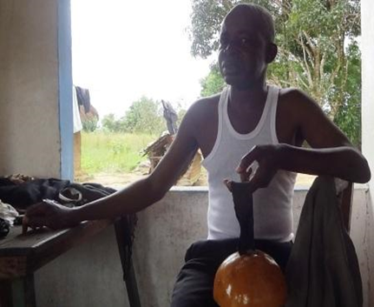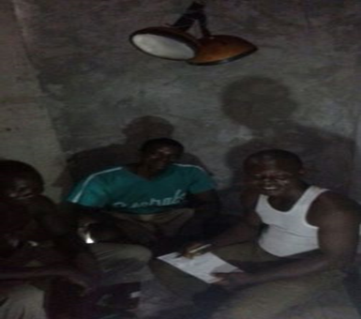

The Solar water pump

SLCBO is an organization who aimed at improving the lives and conditions of the poor in communities in Sierra Leone, Bonthe Island in particular and the construction and rehabilitation of solar water pump for clean and safe drinking water is one of the priorities.
Leading to the death of many people especially women and children in the last five (5) years in the Bonthe district communities, southern Sierra Leone, particular attention needed to be given to needy communities to save the lives of these women and children if we may not want them to perish. As the saying goes, ‘health is wealth’, If the absence of good health does not only threaten the development of grass root communities but also facilitate hunger, starvation and death, then good health is demanding and requiring a comprehensive understanding of the cause of sickness and the possible tools that could be used to prevent sicknesses like cholera and malaria from spreading and destroying the lives of innocent souls.
The implementation of projects to build solar water pump, has aided the mindset of the people of Bonthe of been neglected of good life and development because of their poverty conditions by society and welcome good living into their daily lives.

Public feedback

From the opinion of the solar pump beneficiaries communities in Bonthe, before the solar pump, there were existing uncovered water wells in the community but were not pure and clean for the drinking.
I asked the people why they were saying that, they respond that, the water they access from the solar pump now is colorless, odorless and free from dust and other particles compared to the uncovered wells. For these reasons, they feel safe and secured in the community.
In one conversation, a business woman (selling cooked rice) where most people gathered in the morning to eat admitted that there are not
many complaints about cholera in their community and believe that it was because of the clean and safe drinking water we provided.

Lots of women also confessed that the work load has been easy for them lately since they had the solar water pump in their community. Because it is much safer for their children to go and fetch water by themselves in comparing to the water wells where they have to go fetch the water alone or with their children because it was prohibited only for children to go to the water wells, for the fear of falling in the wells.

From my observations and the opinion of the general public, I concluded that the solar water pump is in perfect working condition and serving the intended purpose as proposed.
Lastly, they also believe that the project was a successful and good one and also pleaded to the donors to provide more so that the entire community can benefit from what they are enjoying.

Pictures at the solar water pump station

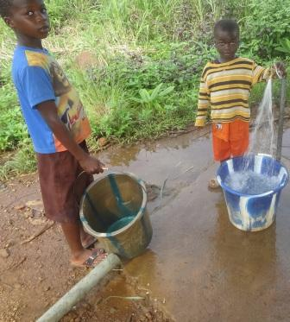
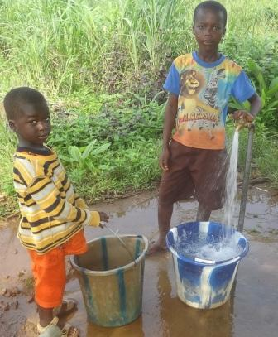
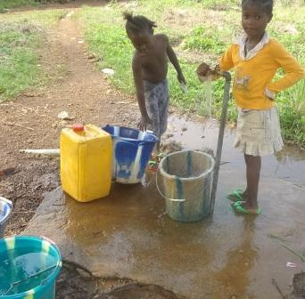

Going forward and having completed a pilot project testing out different simple solar lamps in the community we are now ready to launch a series of projects to light up as many households as possible.

We have selected the following solution:
Item | NAME | REF. IMAGE | Description
 |  | .
SS-CL041C | Solar AC  &DC led light  2000mAh | 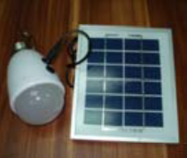 | Optional for E27/B22/E26 lamp holder;  Solar panel: 2W with 5m cable;  Lithium battery: 4000mAh;  Full charging time: 12-13hours;  Working hours: 10-12hours; with remote controller

Appreciation

On behalf of SLCBO, Bonthe Municipality council and the entire Bonthe community, we wish to extend our sincere thanks and appreciation to all well-wishers, Solar Energy Without Borders together with Maridalen Rotary Club who donate the money for the rehabilitation of one water well and the installation of the solar water pump to the people of Bonthe town community. We say thank you and we are grateful.

gracias

kiitos

thank you
arigato
merci
takk
bedankt

tak
grazie

shukrani

danke

