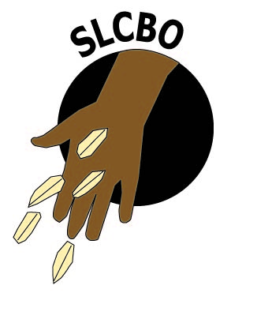
Motto: EMPOWERING THE COMMUNITY
Address: 54 Pie Mary Street, Bonthe Town.
Contact: +4795021584 / +232 76 505 224
Email: slcbo.org@gmail.com
Website: www. Slcbo.org

PROJECT REPORT – CONSTRUCTION WATER WELL AND THE INSTALLATION OF THREE (3) HAND PUMPS (ONE (1) AT THE BISSAU COMMUNITY AND TWO (2) AT THE BONTHE MUNICIPALITY IN THE BONTHE DISTRICT

Construction a water well and the Installation of hand pump at the Bissau community school

SLCBO-HPHT is a community based organisation aimed at improving the lives and conditions of the poor in communities in Sierra Leone and the construction of water wells and the installation of hand pumps for clean and safe drinking water is one of the priorities of HPHT.

In 2012, Help People Help Themselves (HPHT) constructed five (5) meter water well at the Bissau community school which provides clean and safe drinking water for the children as well as the people of entire Bissau community who previously used the same river not only for drinking, fishing, laundering, bathing, and even defecating.

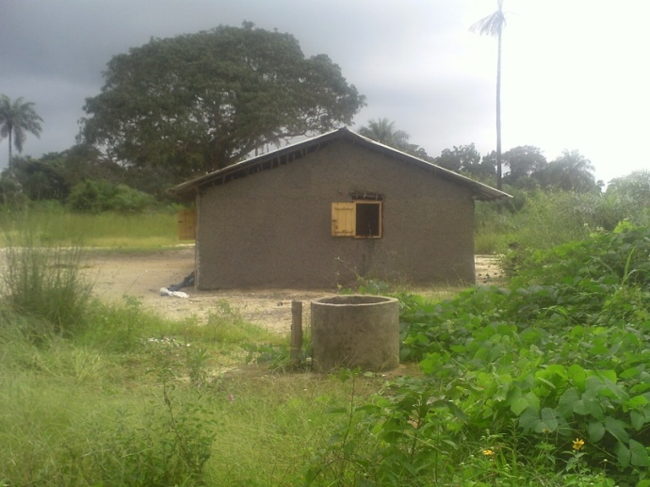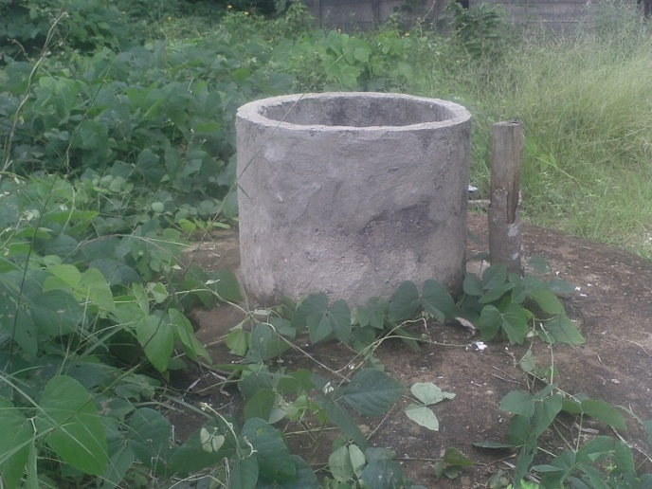
A: Water well
Before the water well, the people of this community used the stream to fetch their drinking water, cooking water, and water for other domestic purposes at the same time, the same stream is also use for bathing, laundry and defecation. For these reasons, over the years, the people of this community have suffered greatly from water born diseases like cholera and other diseases like malaria from mosquitoes. In the dry season especially, when 80% of the stream is dry and the water is stagnant. The mosquitoes are able to breed which causes the spread of malaria in the community. Also with that steady water with which the community uses for all sorts of domestic purposes will become contaminated and in many cases people lose their lives in cholera outbreaks especially children and women.
For all these reasons, HPHT has funded the construction of three (3) hand pumps – one at the Bissau community and two at the Bonthe municipality to provide clean and safe drinking water for the community.

On the 26th September 2013, we received a sum of Le 9,400,000 for the implementation of a hand pump project at the Bissau community school in the Sittia Chiefdom, Bonthe district.

We hired a vehicle from Freetown to Yargoi and arrived at Yargoi at around 3:00 pm. we boarded a boat from Yargoi to Bonthe and arrived at 7:00 pm where we spent the night. The following day, we hired a boat from Bonthe to Bissau village. After an hour and half, we arrived at the village; we transported the materials to the site and gathered the villagers for the construction. After hours of working, we cast the pump cover (slab) closer to the water well which was the first stage of the installation. We left the concrete slab for drying for four (4) days as advised by the technician. With the help of the community, we cleaned the surroundings of the water well and later departed for Bonthe.

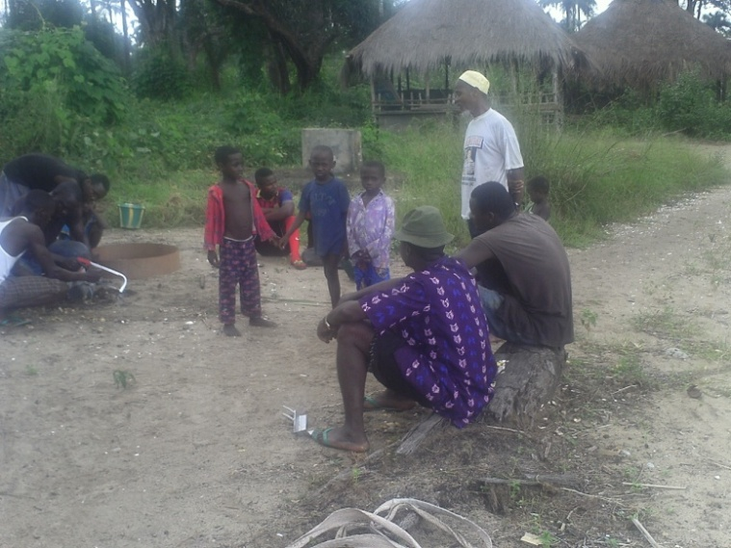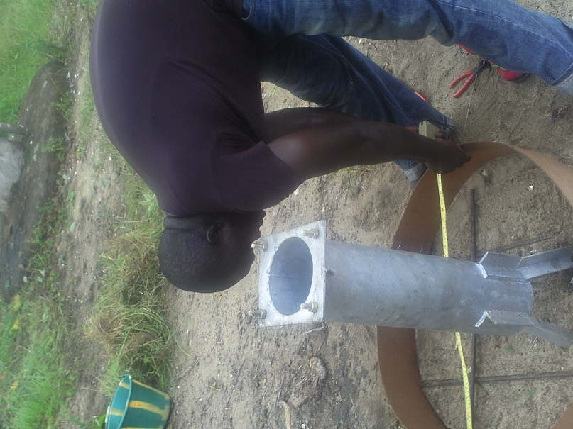

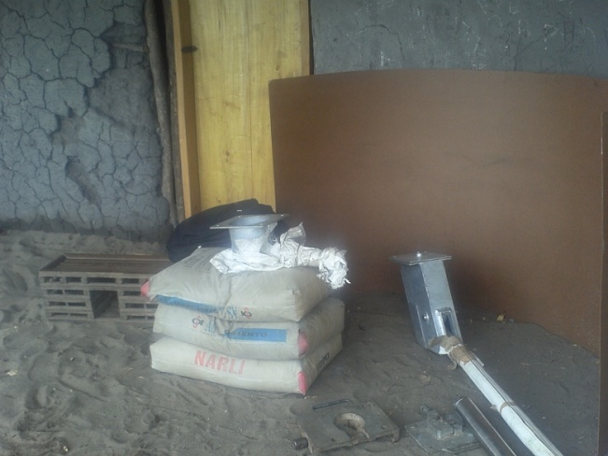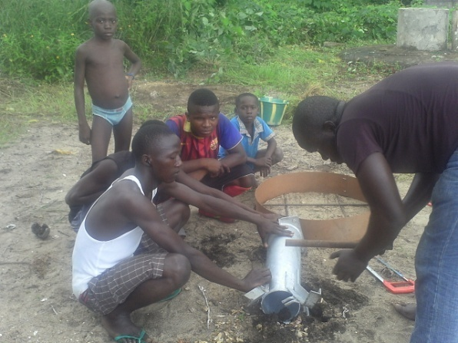

B: pump installation stage 1

After four days, we went back to the village to embark on the final stage of the installation. At this stage, almost all the water in the well was pumped out by a submissive water pump, thoroughly cleans the well and inserts some anti bacteria (chlorine chemical) into the well so that any bacteria, dirt and germs are to be destroyed and completely purified the water. After finished purifying the water, we finally mounted the cast cover (lid) on the well manually, with the help of the community and the technician assembled all the remaining parts of the hand pump and completely seal the well which make it a clean and safe drinking water for the entire community.

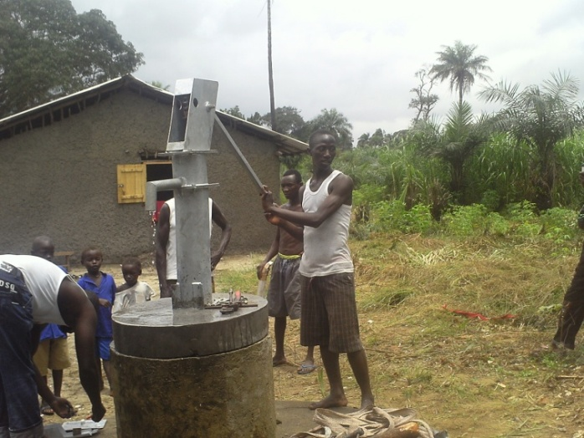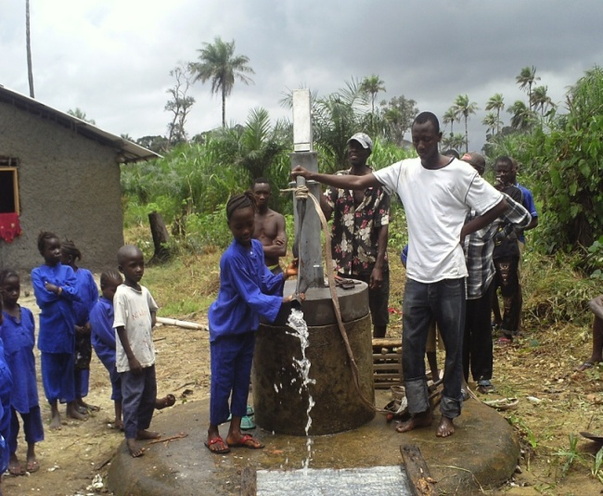

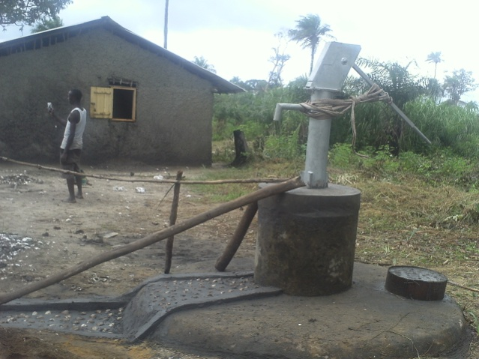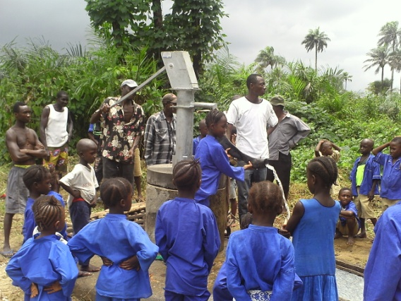

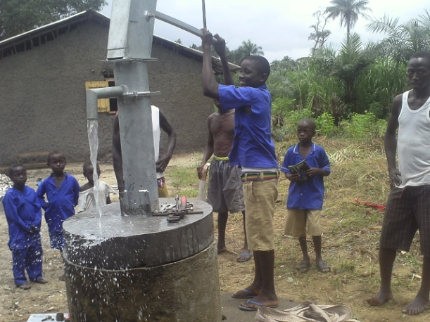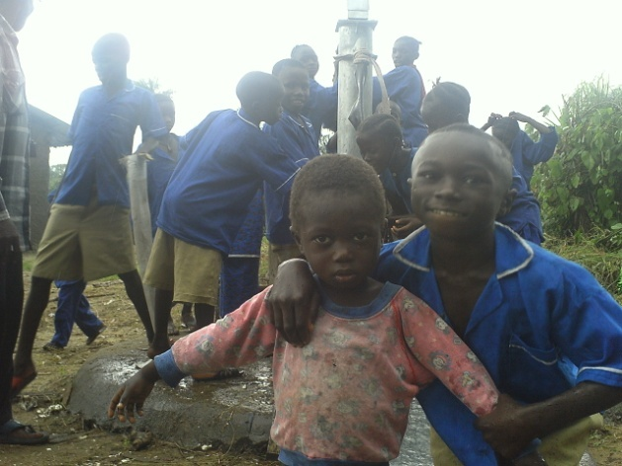

C: pump installation final stage

With the help of Help People Help Themselves, this five meters (5m) depth water well at the Bissau community school which was fill with dirt’s, cockroaches, dead animals and bad odors now provides clean and safe drinking water for the children as well as the entire Bissau community who previously used the water well. The well was completely abandoned by the people because it was opened and lots of animals were finding their way into the well. Before the water well, the community was using the same river not only for drinking, but also for fishing, laundering, bathing, and even defecating.

Currently, more than four hundred (400) people including the entire community and the travelers who do pass by the pump have access to safe drinking water, because the well is located at the cross road that leads to the other sections in the same Sittia chiefdom.

Thanks to SLCBO – HPHT and its well wishers, more people are saved especially the children.

THE INSTALLATION OF TWO (2) HAND PUMPS AT THE BONTHE ISLAND MUNICIPALITY

The Second Pump

On the 10th October 2013, we received a sum of Le 9,000,000 for the installation of a second hand pump project at the Bonthe Island municipality which is located at Pie Mary street , Bonthe Island.

The procedures in the installation of the second pump are the same as the first installation but no hiring of boat was involved.

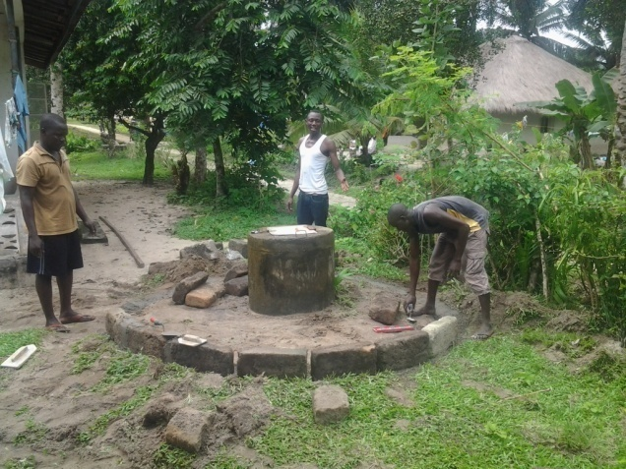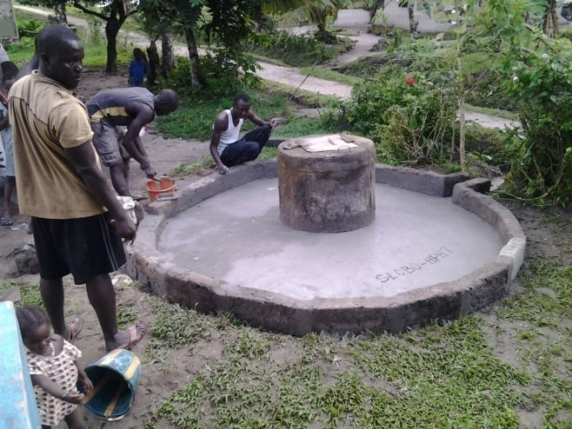

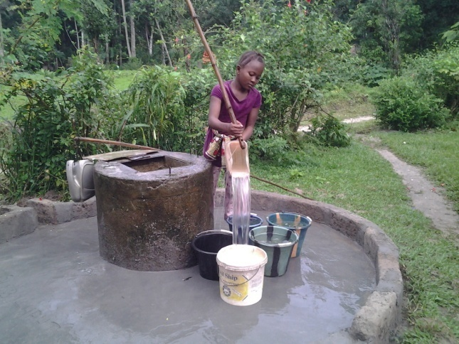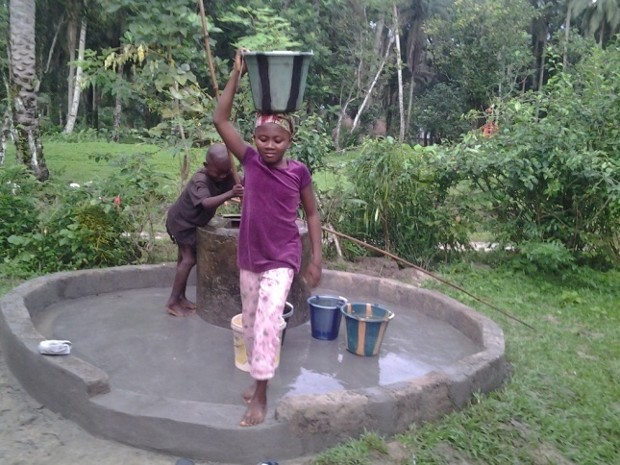

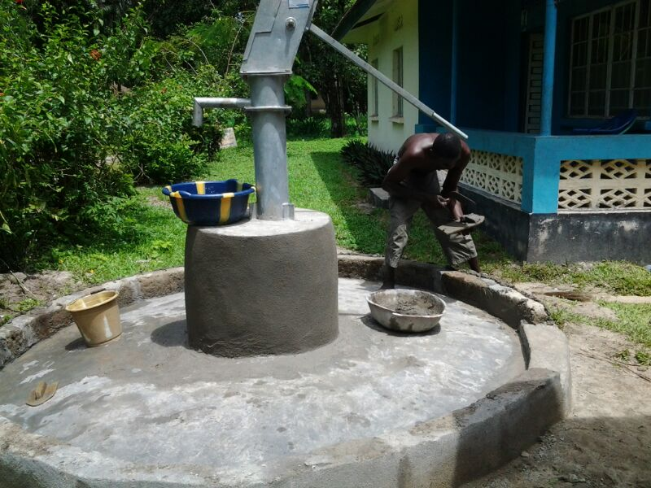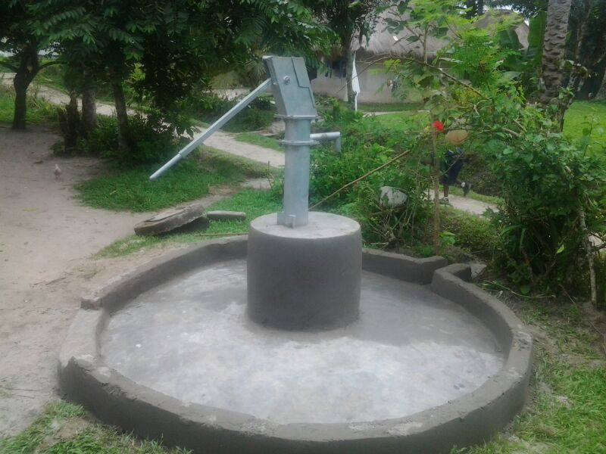

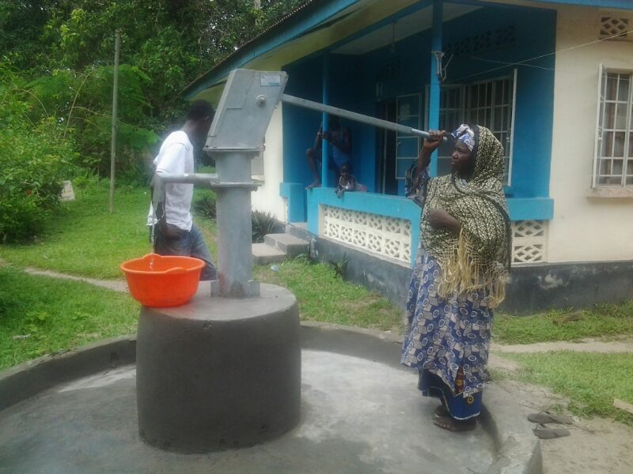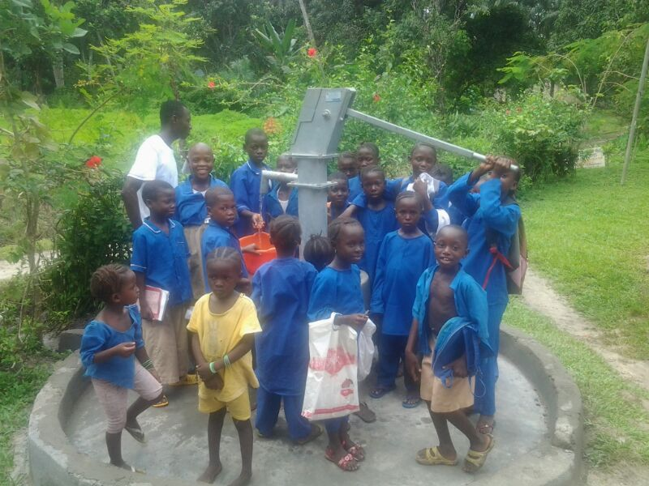

D: pictures showing the full stages of the installation of the second pump

With the help of Help People Help Themselves, these four meters forty feet (4m 40ft) depth water well at Pie Mary Street, Biankoi section, Bonthe municipal now have clean and safe drinking water for the entire section that previously used the water well.

This well was functional with more than five hundred (500) people including school going children accessing it. This well was selected because it is located on the road that leads to one primary school (Islamic call society primary school) and two secondary schools (Dramany secondary school and Bonthe secondary school). So beside the people living around the pump, lots of children do access this pump on their way to and from their various schools but mostly during lunch periods.

Currently, more than five hundred (500) people including the entire community and the school going children have access to safe drinking water.

Thanks to SLCBO – HPHT and its well wishers, more children and people are saved.

The Third Pump

On the 5th November 2013, we received a sum of Le 9,000,000 for the installation of the third hand pump project at the Bonthe Island municipality which is located at the cross road of Edward street and Claffy lane, Bonthe Island.

The procedures in the installation of the third pump are the same as the first and second installation.

During the third pump installation, an additional amount of Le 4,000,000 was needed since the water well was the biggest and the well needed general repairs as shown from the pictures below.

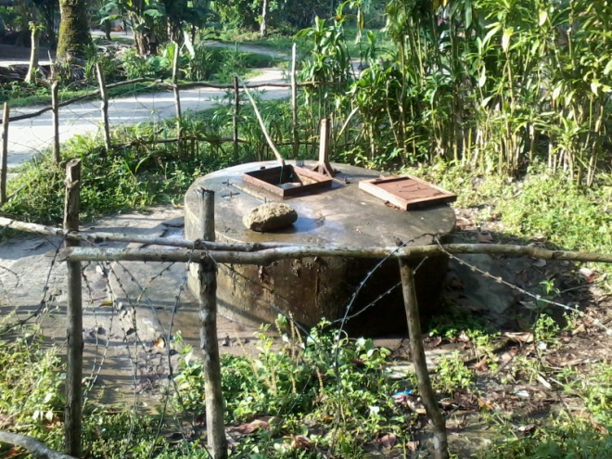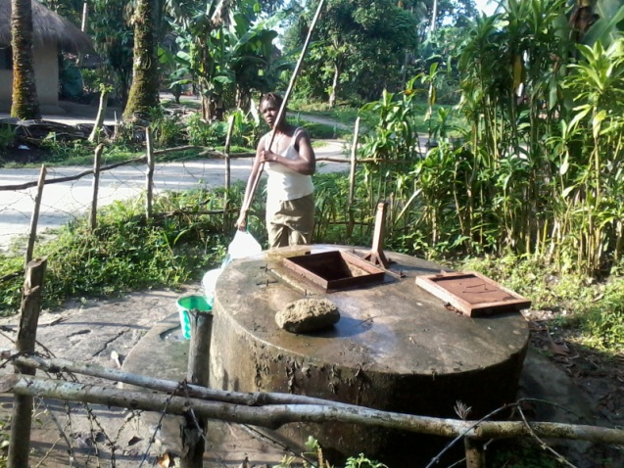

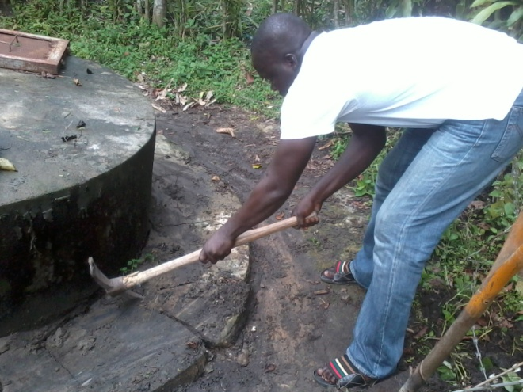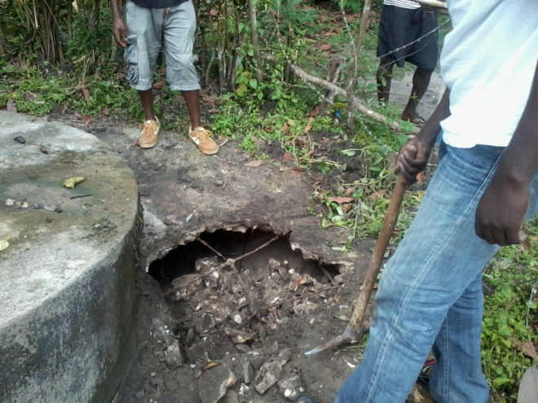

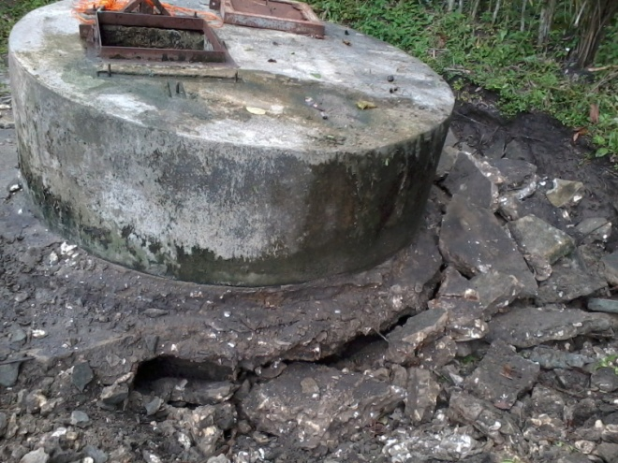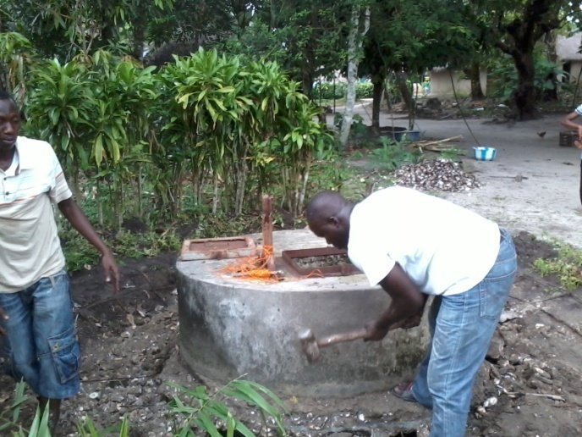

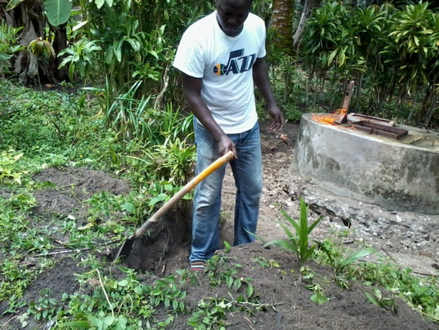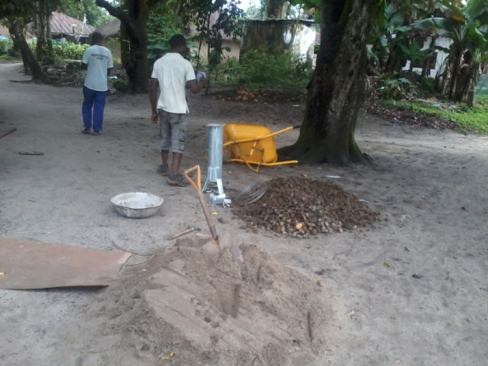

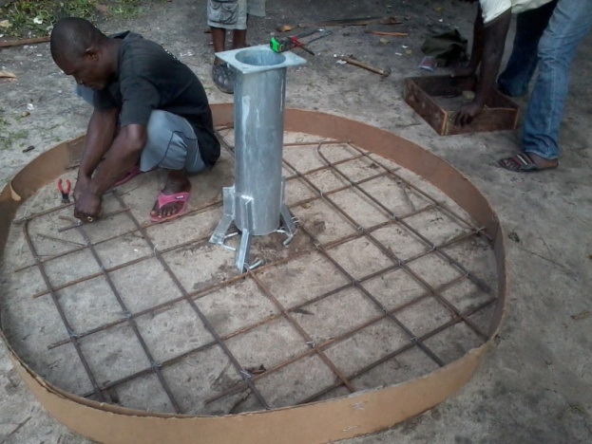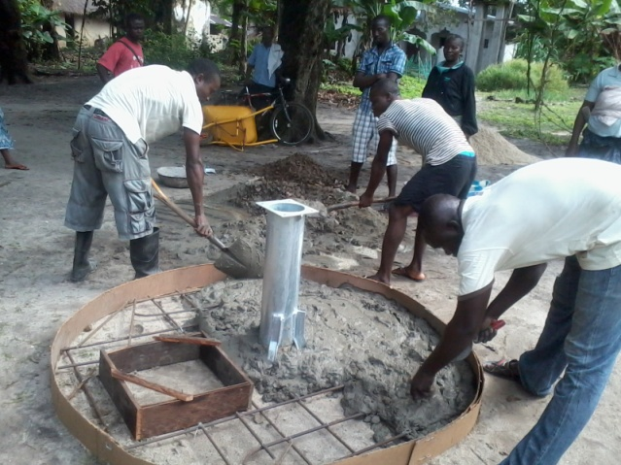

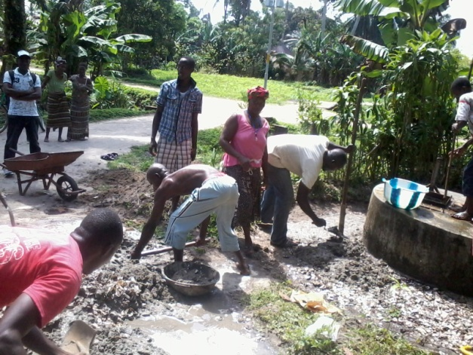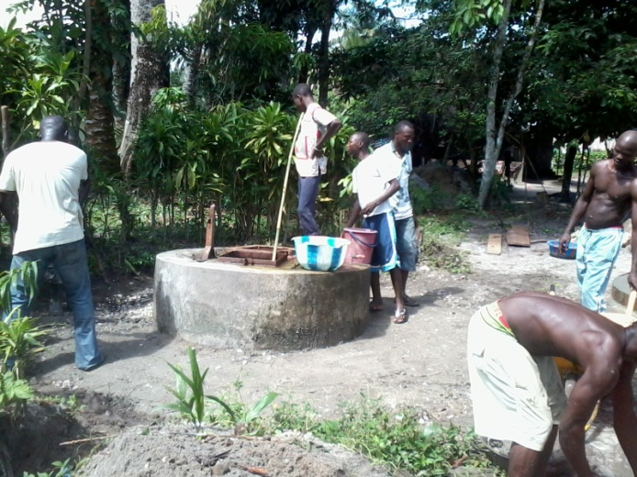

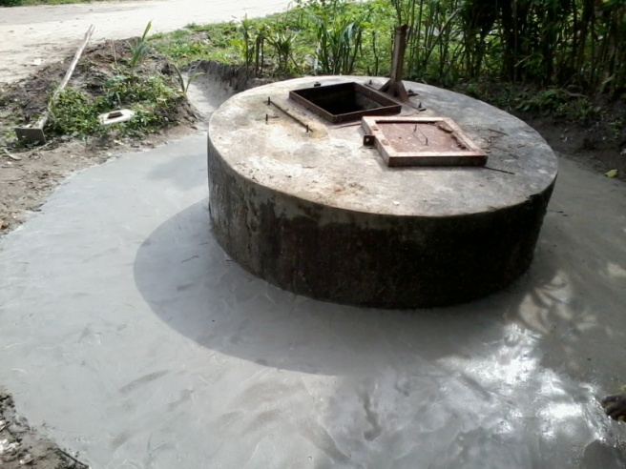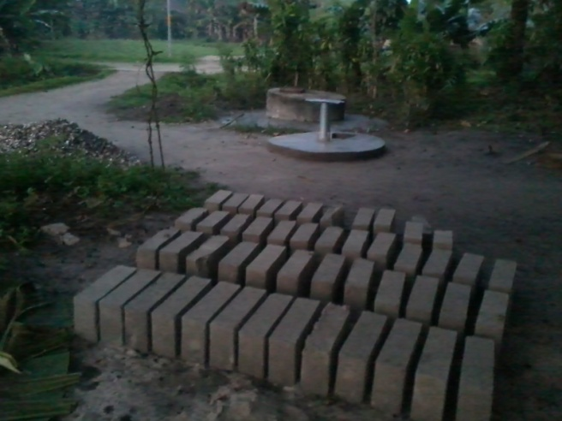

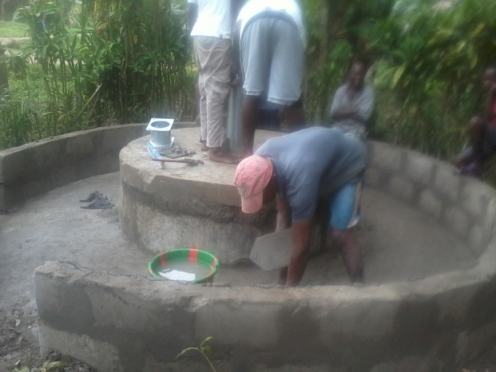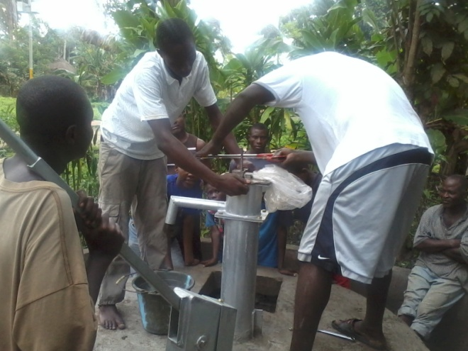

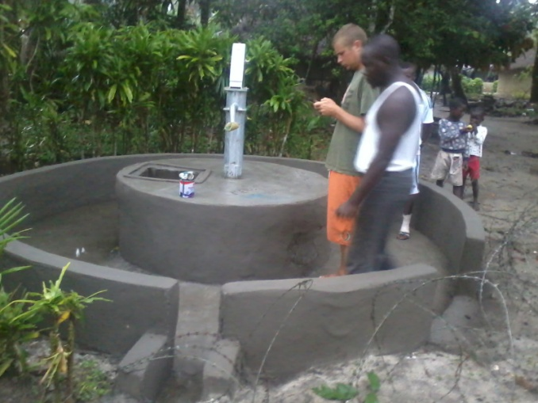

E: The pictures showing all the stages of the installation of the third pump

With the help of Help People Help Themselves, these four meters fifty feet (4m 50ft) depth water well at the cross road of Edward Street and Claffy lane, Fonima section, Bonthe municipal now have clean and safe drinking water in some portion of the Fonima section and some portion of the Jundu section that previously used the water well.

This well was half way lean from the back as shown from the pictures but functional with more than four hundred (400) people accessing it. This well was selected because it is one of the oldest water wells in Bonthe municipality and this community has been taken good care of this water well like cleaning and chlorination. It was first constructed by CARE during the Sierra Leone Civil war more than seventeen (17) years ago. Five years later, it was rehabilitated by the Sierra Leone Red Cross Society. Over the years, survey conducted shows that all the wells constructed by CARE are non functional except the Fonima section well. This well was in a very bad condition almost on the verge of abandoning until SLCBO – HPHT steps in.

Currently, more than four hundred (400) people in two sections in Bonthe municipal and the children have access to safe drinking water.

Thanks to SLCBO – HPHT and its well wishers, more children and people are saved

CHALLENGES DURING THE INSTALLATION OF THE BISSAU PUMP

During the installation, we found out that there was a wide gap between the first three cylinders and the three last once in the water well at the Bissau community. Meaning, there were six cylinders that make the full length of the water well but the first three cylinders at the top is suspended (separated from the last three cylinders) and the last three at the bottom is suspended (did not reach to the bottom of the well). The reason was because the cylinders were not given enough time to settle before the concrete work on the outside of the well is done. This information is necessary for future purposes.

CHALLENGES DURING THE INSTALLATION OF THE THIRD PUMP

There were a lot of challenges during the installation of the third hand pump:

The third pump was twice lager than the first and second pumps

The cost involve was almost twice the cost of the two previous pumps

This well is more than 15 years

The well needed both general repairs and pump installation

More time

The well was broken and lean from the back

Despite some minor setbacks like the submissive water pump not working, the cooperation and commitment displayed by both the technical team and community people led to the successful installation of the hand pumps in Bonthe as well as Bissau village. The hand pumps after installation was successfully launched in Bonthe and Bissau village. The success of the launch was marked by an immediate open of the pumps to the school children and community at large.

