PILOT

SOLAR KIOSK   
IN   
SIERRA-LEONE

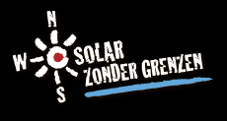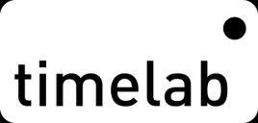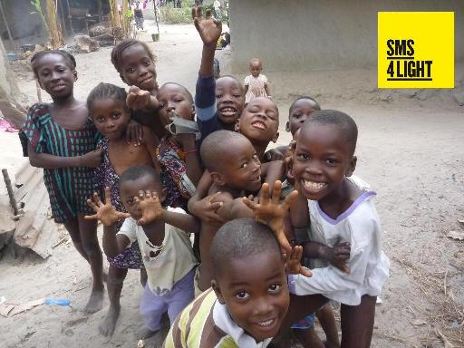



BACkGROUND and project concept

In West Africa, 561 million people still have no access to electricity.

By the lack of electricity, the alternative solutions to illumination are very expensive, unhealthy, of poor quality and harmful to the environment.

Although these regions have the highest potential for solar energy, the major obstacle for solar installations remains the high cost to the end user.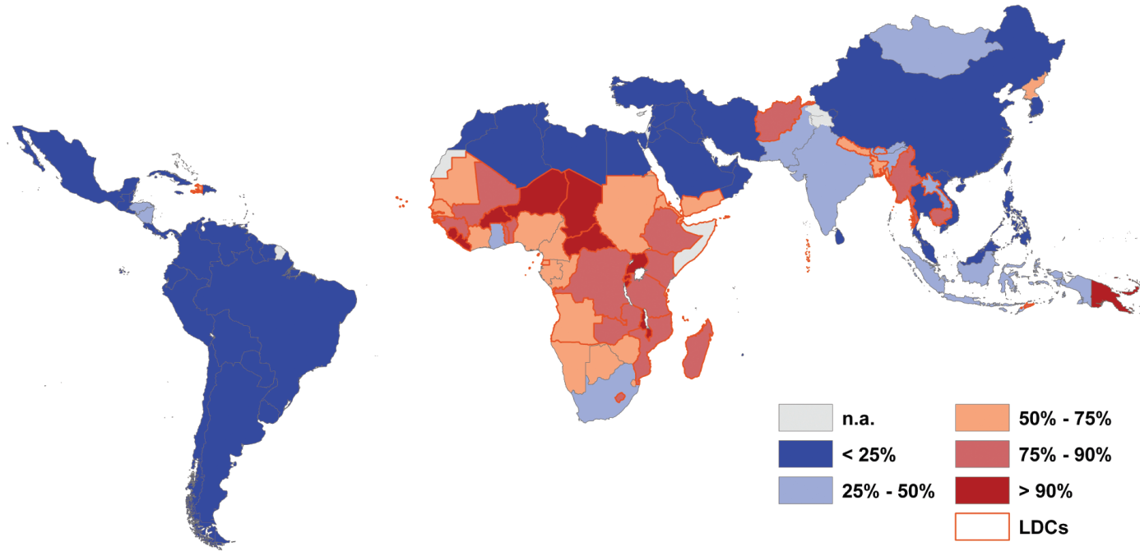

“Solar Zonder Grenzen - SZG” which translates to “Solar Without Borders, sought to remedy this making even the poorest people have access to decent lighting in the common use of a central charging system. This system was technically and logistically worked out and has been named "The Solar Kiosk".

“A Solar Kiosk” is a central building, equipped with a solar installation, on which the neighborhood can charge their lamps. The solar lamp is composed of a circuit developed by SZG with Timelab (Belgium), an optimized LED lamp and a rechargeable battery that provides 11 hours to light. The rented discharged lamp can be exchanged for a charged lamp at the Solar Kiosk. Using 1 central charging system reduces the costs for the costumer, in this way we can even reach the poorest people to provide light.

By using the 'Solar Kiosk' model:  
-Economics: the end user pays less compared to the current opportunities (flashlights, kerosene lamps).

-Ecological: The lighting is brighter, more user-friendly, healthier and not harmful to the environment. Everything is produced locally using local materials.

-Sustainable: By providing training and workshops employment and entrepreneurship will be stimulated. By using easy and local materials, damage can be easily repaired by the kiosk keeper.

The solar lamps are offered for a low monthly rent:  
The solar panel and solar installation will be inspected every 2 years. After 10year the collected low monthly rent can be used to replace the panels and batteries. That way the Kiosks will fund themselves and take care of its future existence.

By providing this solution through workshops and training, SZG wants to encourage entrepreneurship and create independence. The Solar Kiosks are manufactured and installed for and by local people with the permanent guidance of Solar Zonder Grenzen.

STEP 1 - TRAINING OF LOCAL TEAM IN FREETOWN (SIERRA LEONE)

-Financial support: 'Solenergi Uten Grenser – ' (which also translates to Solar Without Borders) founded and headed by Mr. Tommy Fernandes (Norway) and ‘Solar Zonder Grenzen’ (Belgium)

-Partner organization in Sierra Leone founded and headed by Mr. Isaac Mansaray (currently based in Norway):   
SLCBO (Sierra Leone Community Based Organization):

-Implementation and use of buildings and facilities for the training

-composing a team that would follow the training and helping developing solar kiosks

-Elaborate preparations and compiling the necessary local materials

-Project Executor: Solar Without Borders (Belgium)

-Setting up a temporary local lab

-Train a local team to produce 120 Solar Lamps

-Installation of the first pilot kiosk

Through the cooperation and support of DHL, we could transport the heavy equipment to create our little lab.

On request and supported by 'Solenergi Uten Grenser' we had the opportunity to set up this pilot project in Sierra Leone. The initial demand was to provide a solar kiosk at the isolated village “Bonthe”.

SZG does not focus in deploying Solar Kiosks, but in educating a team and teaching them how to manufacture solar lamps thus providing light in their own local community by their own efforts - Lamp by lamp, kiosk by kiosk.

In this way we try to encourage entrepreneurship and independence and we created the possibility for an initial pilot project for Sierra Leone.

To accomplish this program, a lighting circuit has been optimized, developed for simple local production.  
To reduce manual precise operations, a compact "soldering oven" has been developed to create an easy, fast and descent way to produce the light circuits. An ordinary kitchen oven equipped with a connected program box controls the heating process and “bakes” the light components at the panelized prints using solder paste.

A local SLCBO-team was ready to start from the moment we arrived. In a short space of time the setup of the lab was done and we started to inform everybody about the lamps, the process to make them and the steps of production. From the first minute the interest and concentration were very high. All production details were absorbed by the group, and have been passed on very precisely.

The light circuit was distilled so every step was easy to learn and understand. Production was taught in clear steps so everyone could execute each action several times and get familiar with the process.

The use of the soldering oven, manual soldering, the programming of the lamps and in particular controlling a faulty lamp and its repairs were quickly learned. With statements like: "Hey wait, let me do it. I think I see what the problem is ... ", you know you’re on the right track

The determination of the team and good internal communication (everyone checked and offered help to each other) made production run very smoothly.   
“Catching” someone in the afternoon repairing his 6 month broken lamp is a nice confirmation that the techniques are mastered. “No need to help. It’s just a little bad connection, easy to solder”.

A nice change after 4 days of concentration is to develop the lamp housing. While one part of the group finishes the lamp circuits, we search for the smoothest production method for the Calabash-lamp housing with the other team. Once we found the best way to produce them, both groups came together to teach and help each other

The team decided to take a walk at nightfall with the 1st lamp and to introduce in in the nearby village.  
One by one, the suspicious villagers take the lamp to subject it on their critical inspection.  
The news this lamp is made through and for their own people dissipates quickly distrust. The possibility this project will be distributed so everyone gets a chance to have a solar lamp makes the women start nod and cuddling approvingly.

Even more, we experienced that the presence of light determines success or failure of solar lamps in the African nights. At 5 pm, women start preparing supper, well knowing that darkness will hit soon. At 6pm it is lights out and pitch dark. After the children have been fed and tucked in to bed, mum and dad can eat quickly in the dim light of an oil lamp or flashlight.

The discussion continues and everybody is talking about the impact of light on life after dark. The few generators do offer some light. But they make a horrible noise, puffing black smoke and devour gallons of expensive kerosene. The cheap flashlights are in use, but the quality is plummeting backwards. This results in gardens dotted with empty old batteries.

After only four days the 120 lamp circuits were finished. At day 8, the last circuit has been build and finished in the Calabash housing.

Based on the high focus and enthusiasm of the production team, the cravings of the population to own self-produced, decent and affordable lighting, this project shows promise that much positive change can be achieved in the community.

**The training of a local team to install a pilot project for Sierra Leone was funded by Solenergi Uten Grenser (Norway) and Solar Zonder Grenzen (Belgium).**

**The local support was prepared and made possible by SLCBO (Sierra Leone Community Based Organization)**

**The technical optimalisation of the light circuit has been done by Timelab (Belgium) and Solar Zonder Grenzen.**

STEP 2 -INSTALLATION OF THE PILOT KIOSK IN Bonthe (SIERRA LEONE).

The 120 produced solar lamps, 16 lamp-chargers and solar installation are prepared and loaded for the retreat to Bonthe. In the early morning we leave with a overstuffed pickup. Again the lack of decent roads results in totally isolated villages. Thus the main road is rarely used because of the poor condition of it. After 6 hours of chugging, we leave the car at the coast and transfer the cargo to continue our journey by boat to Bonthe.

On the boat the team tries to pass the time with the presentation of our project and the Solar Lamps.   
As many boat or bus rides are entertained by local preachers, our fellow travelers are informed in the same style about "The New Light"!

Bonthe is a coastal city located on Sherbo Island (the most southern province of Sierra Leone) and once was the cradle of all imports and exports to and from the mainland. Meanwhile prosperity has its downside. The glory years are still visible into Ruins of large buildings, the rectangular street plan and the town structure.

Meanwhile young people migrate to the mainland and Bonthe is slowly abandoned by many and exchanged for the capital Freetown. Despite the exodus of the original population Bonthe remains characterized by its pure and innocent lifestyle, where motorized traffic will not pass in the coming decades. Imagine children playing innocent between the dominant green and the carefully maintained mud huts. A unique and peaceful location, despite the poverty and lack of supply of goods and services. Due to the large distance to the facilities by the continent, the population is forced to reconcile with the rising and setting of the sun.

When we decided to walk around the village and inform the cooking women, we noticed our action on the boat has not only lit our fellow travelers. The news about the solar lights in response to the weak flashlights went through the village in no time after the entertaining boat action. The village was already aware and subjects us immediately to their questions and their critical inspection.

"Hey Whiteman, I know who you are! You’re from the lamps and came with the boat yesterday, right? Be welcome and tell me everything about it ...”

We informed everybody on our journey and invited them for a general discussion at nightfall, where the lamps could be tried and rented at once.

Many interested people came down to the Solar Kiosk and in no time the first lamps found their new home. Meanwhile, we were contacted by the local radio asking to do a story on our project followed by a half hour 'question and answer' where listeners could express their questions. The comments were positive, the few critical turns quickly to refute.

Next morning at departure, already four women appeared asking for a lamp. From this point onwards Ishmail, the proud kiosk keeper who followed the training, took over. He manages the kiosk, charges the lamps, helps the people using the lamp and keeps us informed about the operation of the kiosk. A few days later Ishmail informed us that ALL the solar lamps where rented and a waiting list has been created. Wow! Soon we hope the kiosk will be expanded with another batch of 60 lamps and a 2nd battery.

We chose to offer the lamps at a low rental price to improve convenience for the people to drop their kerosene lamps and try using “new lamps”.

The SLCBO-team put a lot of energy into informing the people and convincing them to try using the solar lamp. After some time the team will come back to learn and see how the people use the solar lamps. They will evaluate how the kiosk performs, talk with the people and get their feedback about the usage of the solar lamps.

"The solar lamps provide better illumination, which extends our days with 2 hours," says a happy woman. This is a very powerful testimonial!

"Our children normally must go to bed at 6pm because of the dark, now they can stay playing or do their homework for an hour while I watch from the cooking shed. This light spreads more so I can still watch my kinds while I’m working around". Again this shows a high degree of user needs being met!

The rent is calculated and set in a sustainable manner. The level will serve for repairing and replacing the batteries and solar panels. In this way, each solar kiosk is self-sufficient as a small business with an economy that is sustainable over time.

This first kiosk of hopefully more in Sierra Leone is now ready and in operation. It has been welcomed with enthusiasm by the employees, the villagers, the village leaders and the Bonthe community at large.

As a pilot project the kiosk will be followed up well and will give us valuable information about the behavior of the charging system and the use of the lamps by its customers. The information obtained will be used to adapt the installation if necessary according to the needs and usage by the customers.

Working together with the team of SLCBO was very pleasant. Besides the high interest and concentration we were pleasantly surprised by the initiatives. A detailed plan was worked out by them to inform the public and to get. "New light" to the user.

We have all the confidence in the cooperation between 'Solenergi Uten Grenser', 'SLCBO' and 'Solar Zonder Grenzen' and hope that this first Solar Kiosk and derivative experiences can be the start of gradually creating a network of Solar Kiosks in Sierra Leone and elsewhere in West Africa.

With the trained team, we can work together to illuminating the neighboring villages. in nearby future, kiosk by kiosk, lamp by lamp, like a light stain spreading out. Every half year the team will be assisted by Solar Without Borders members for checking and optimizing the production process.

Once the production and installation of the kiosk runs good, another training will be giving into the manual production of solar panels.

In this way, the kiosks can be equipped with their own solar panels and maybe later some panels can be sold for individual private use.

At this moment the process for manual production of solar panels is being optimized and tested by Solar Without Borders (Belgium). This process would be launched in the autumn. 2013

We thank everyone who supported the project, financial, practical or with their moral support...

**The production and installation of the first pilot solar kiosk was funded by Solenergi Uten Grenser (Norway), Solar Zonder Grenzen (Belgium) and Niko Lighting (Belgium).**

**The production and installation of the first pilot solar kiosk was installed a local team of SLCBO supported by Solar Zonder Grenzen. The kiosk is now running and is managed by Ishmail, the proud kiosk keeper who has been trained by Solar Zonder Grenzen.**

**The kiosk will be monitored by Mohamed Moipa Zombo, the Technical Manager of the SLCBO team, trained by Solar Zonder Grenzen.**

**The customers will be assisted with the use of the lamps by Ms. Simshe Lois Roberts of the SLCBO team.**

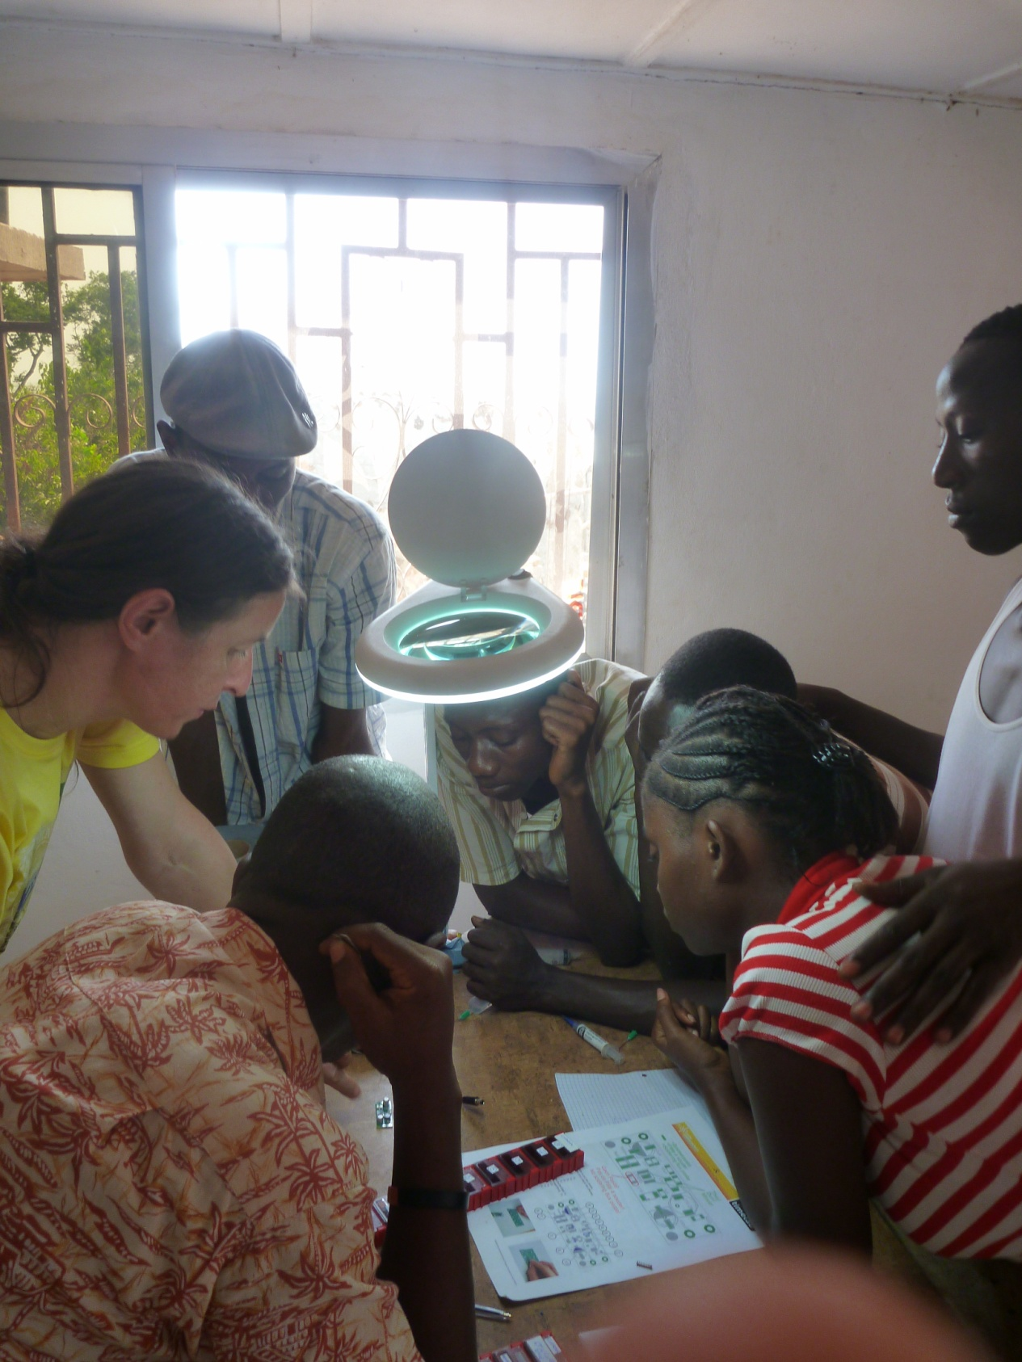

Initial briefing for the SLCBO-team with the technical details of the production of the Solar Lamp and the program for the next days

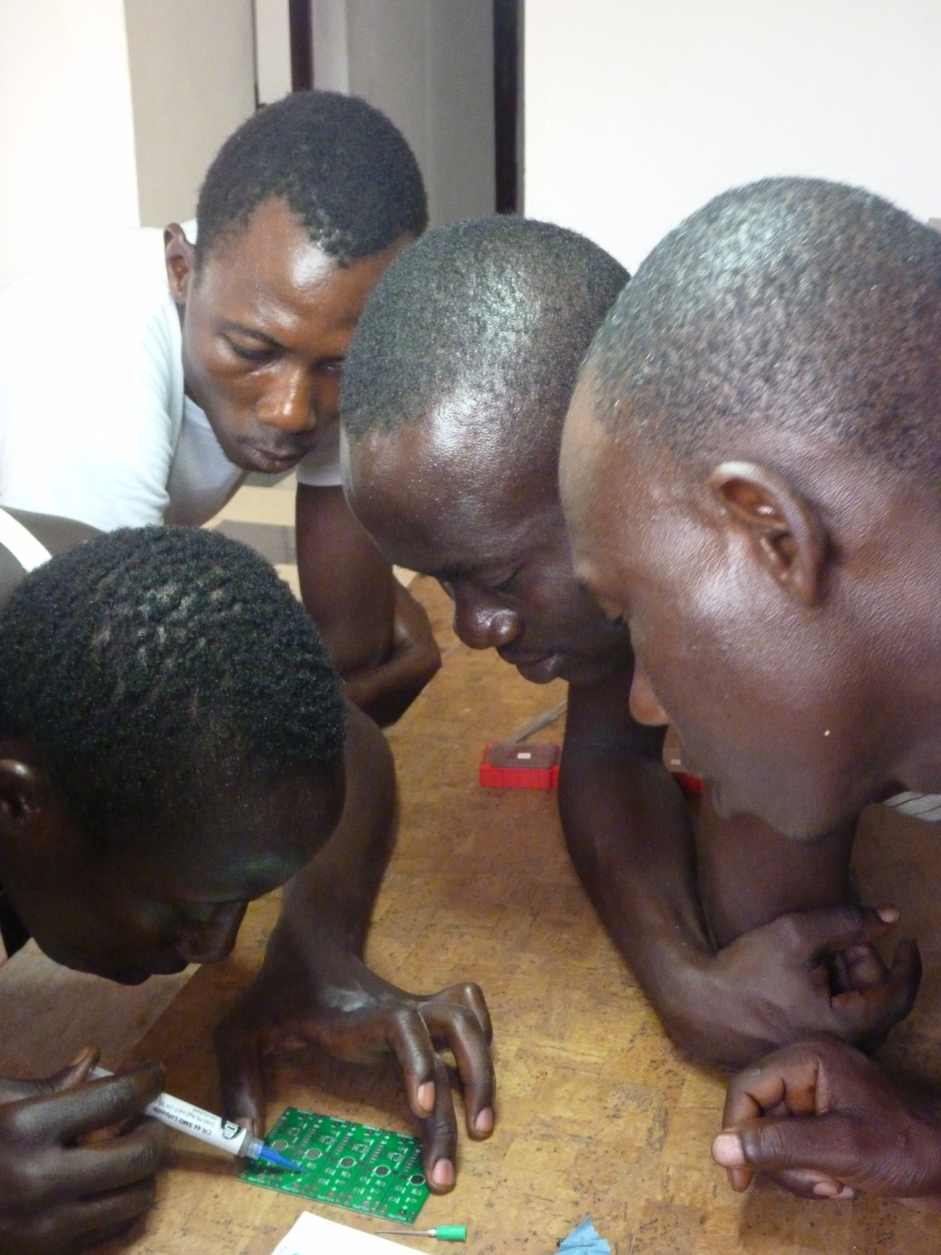

Ishmail, the future Kiosk Keeper, putting solder paste and the electronic components onto the

panelized prints. Here he is repeating the details for his team members.

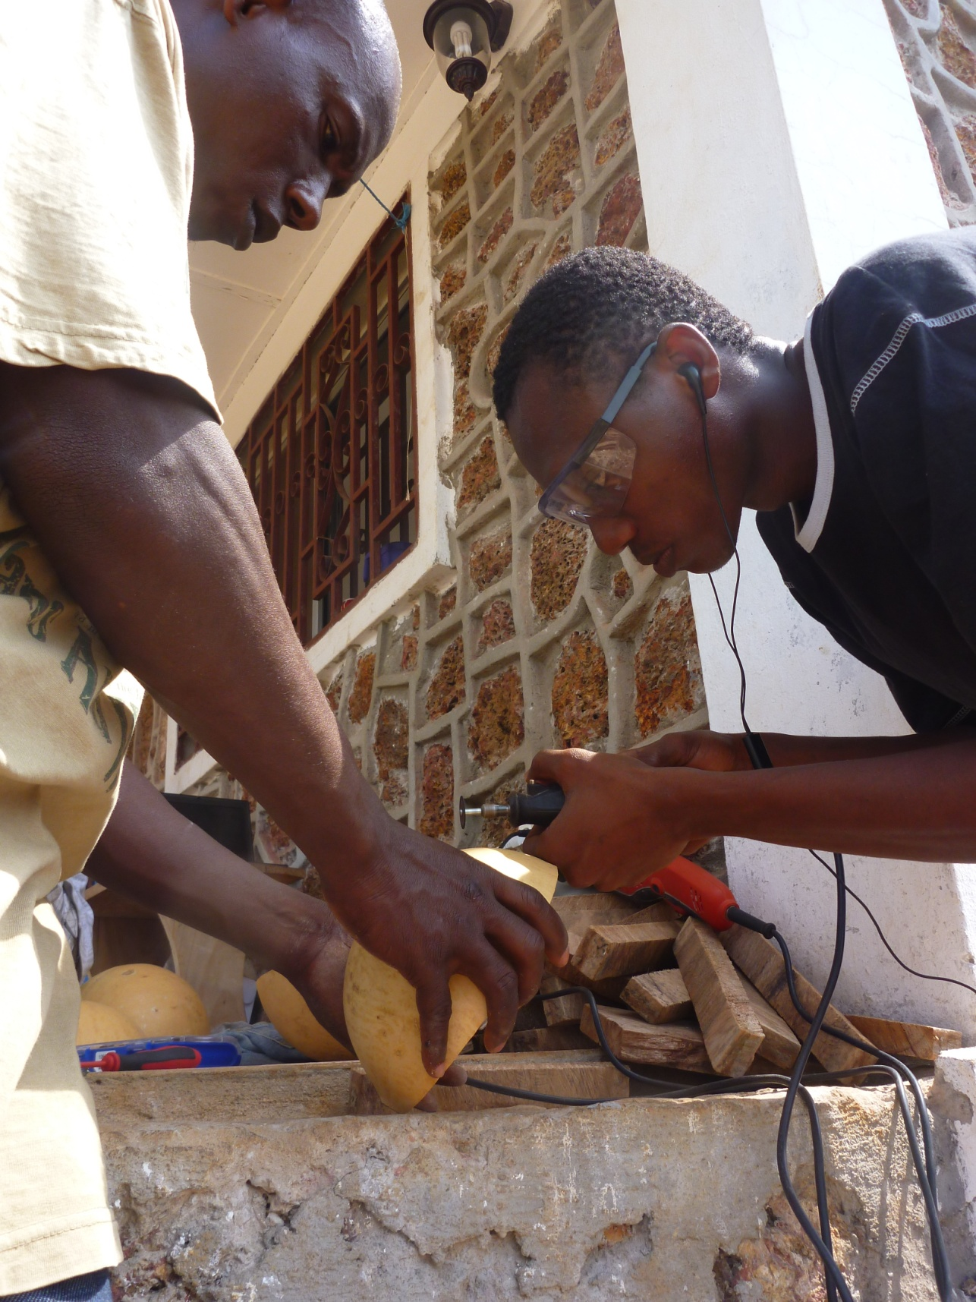

Mohamed has been trained as Technical Coordinator. Besides the training of the other members, he has learned more of the details including possible errors or delicate handling in production.

Here Mohamed is preparing the first calabash lamp housing.

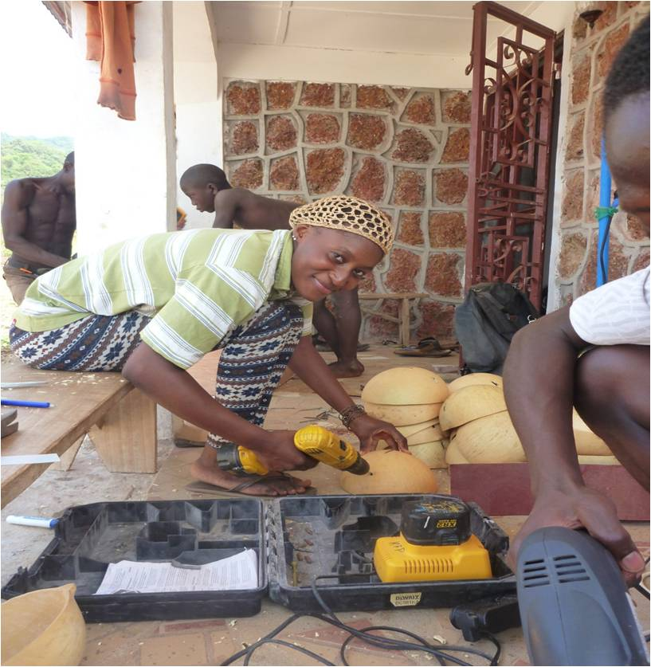

Jitta prepares the first calabashes. Here everybody has been given a particular task (drawing the centers, cutting holes, sawing). After a while everybody switches and passes the details to each other so everybody has done each part of the process…

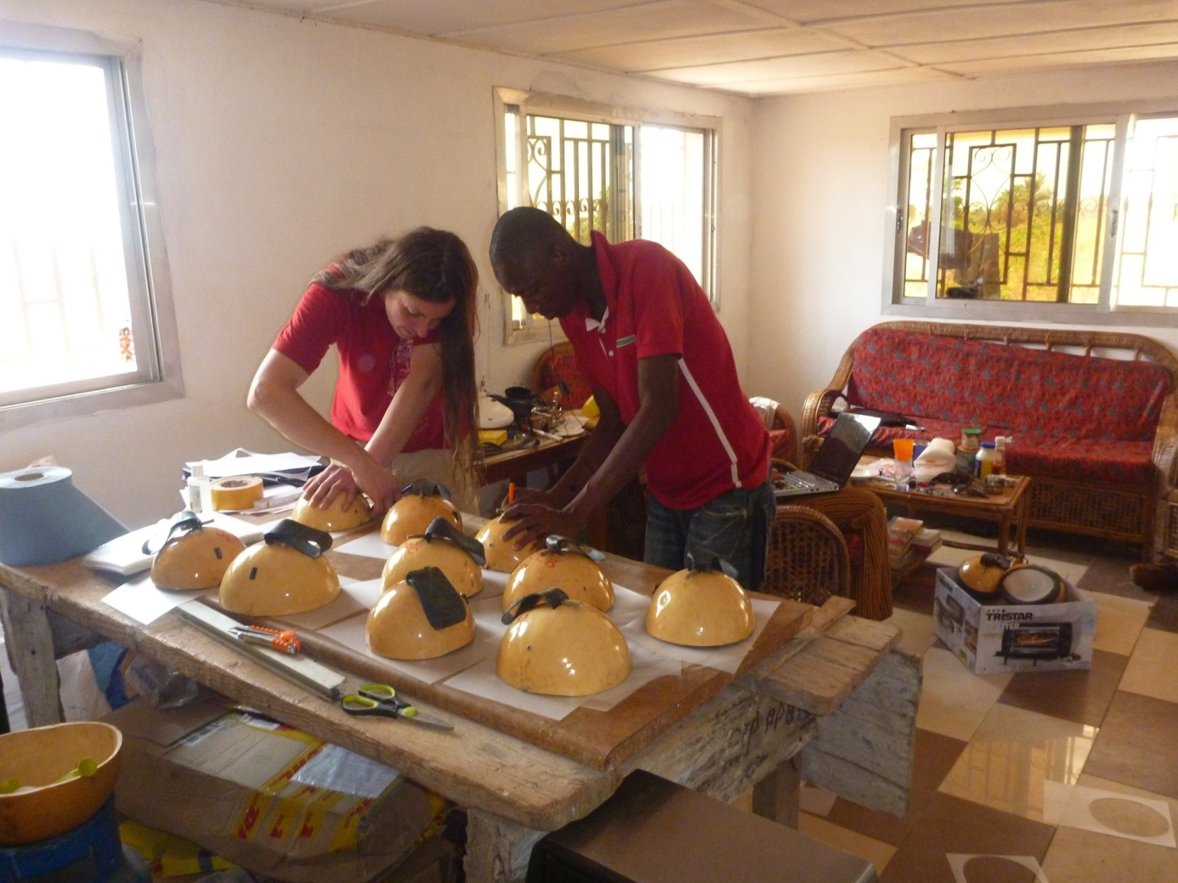Lionel and Osman making the fronts for the lamp housing

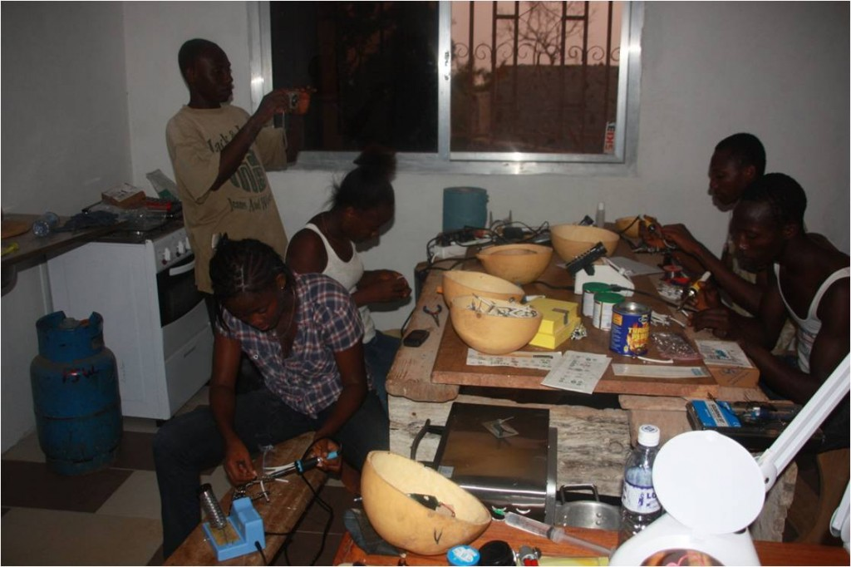Everybody is soldering manually the cables onto the circuits. After this the finalized circuits can be built into the calabash lamp housing

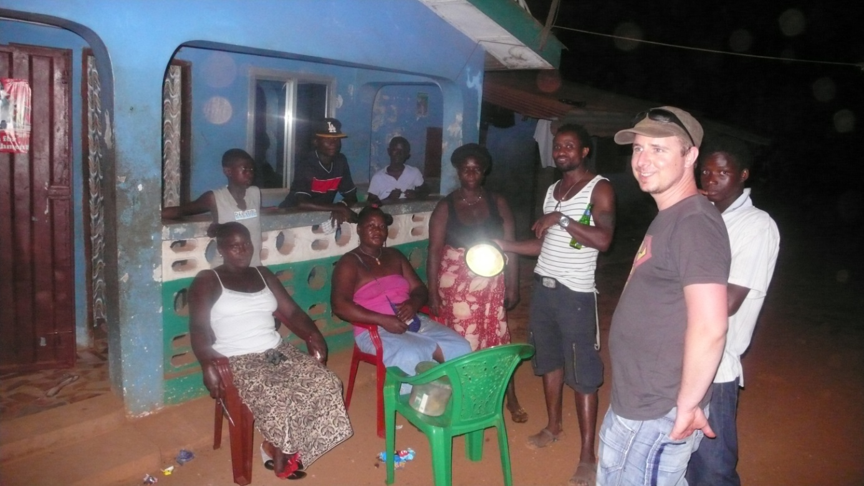Introducing the 1st Solar Lamp into the village.

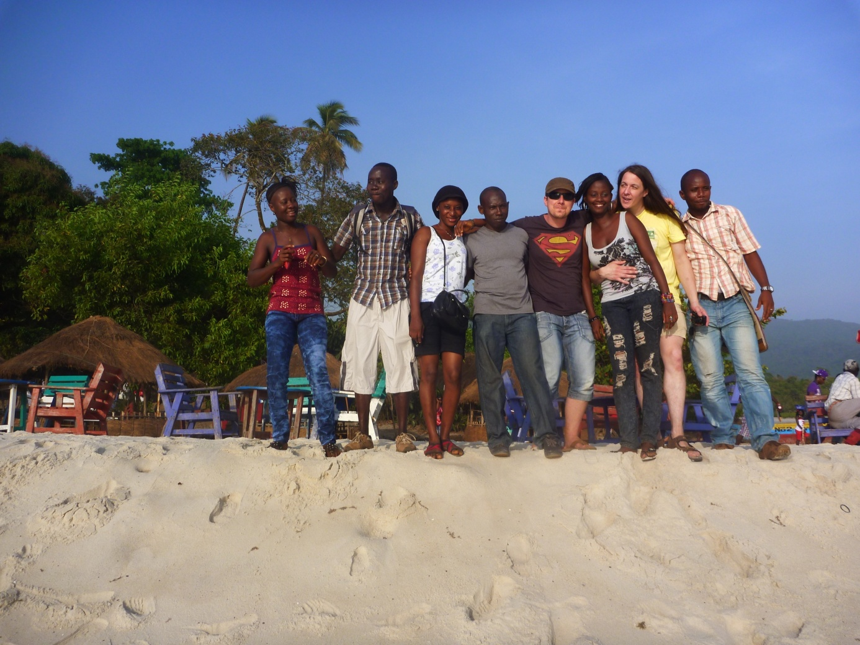

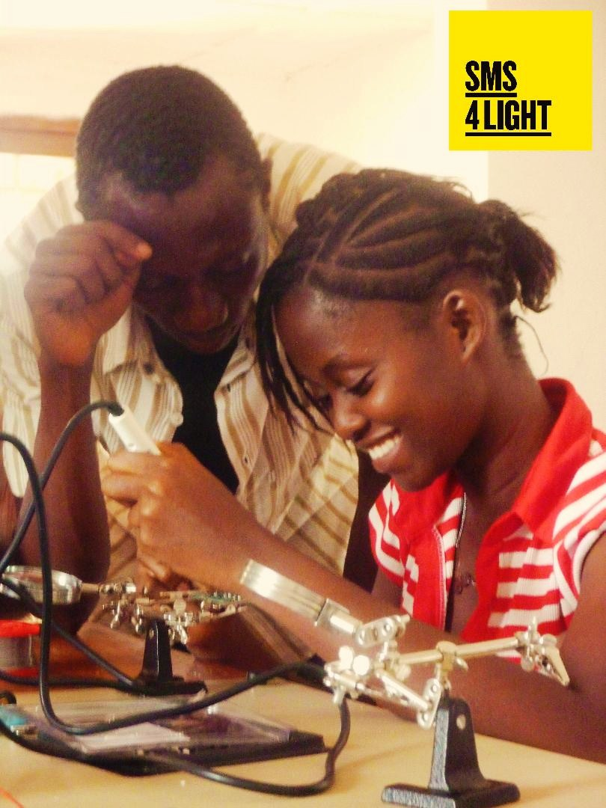Simshe and Mohamed manualy soldering the LED lamps onto the panalised prints.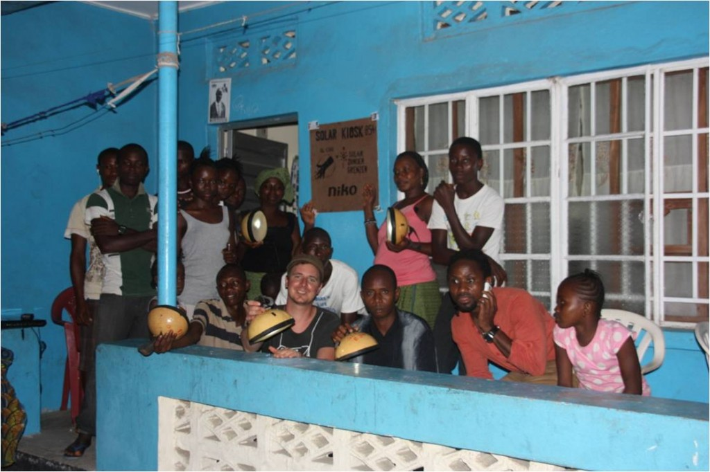Picture just before the introduction evening in Bonthe.  
Everybody has been informed and invited to come to the Solar Kiosk. Here everybody can see the process of charging, how the lamps works and watch the difference with the kerosene lamps.

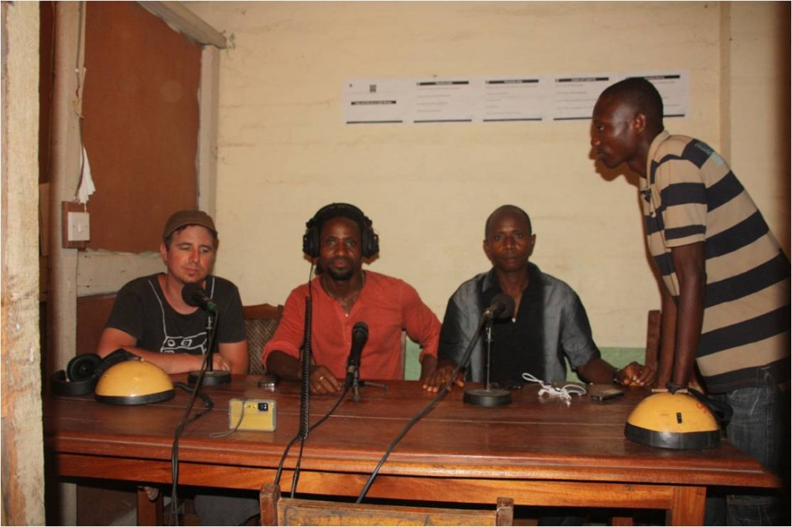Information hour on Radio Bonthe